WEBSITE DEVELOPMENT REPORT
DualPages Books
"Your Story Starts Here"
wasifzaman2047.wixsite.com/mysite
Group Memebrs
- Muhammad Wasif Ul Zaman
- Omamah Naeem
- Muhammad Ahmad Shah
Submit To:
Dr Atif Raza

AICT Academic Project | May 2026

Table of Contents
1. Introduction 2
2. Project Overview 2
3. Our Team & Roles 3
4. Steps We Followed to Build the Website 3
5. Books We Added to the Website 4
5.1 Competitive Exams & Test Preparation 4
5.2 Islamic Holy Books 4
5.3 Urdu Novels & Literature 5
6. Free Plan Limitations 5
7. Online Payment Error — Explanation & Screenshot 5
7.1 Screenshot of the Error 5
7.2 Why This Error Appears 6
7.3 How to Fix This (Future Upgrade) 6
8. Conclusion 6
References 7

1. Introduction
We are three students — Omamah Naeem, Muhammad Wasif Ul Zaman, and Muhammad Ahmad Shah — who built this website as part of our AICT academic project. Our goal was to create an online book store called DualPages Books that allows users to browse and purchase books across three categories: Urdu Novels, Islamic Holy Books, and Competitive Exam Books.
We used Wix, a free website builder, to design and develop the entire website from scratch. The website is live and accessible at:
https://wasifzaman2047.wixsite.com/mysite
Since we used the free version of Wix, some features like online payment, custom domain, and removal of Wix branding were not available to us. These are paid features. However, all the core functionality of the website — including product listings, shopping cart, categories, and checkout — was successfully built and demonstrated.

2. Project Overview
Field | Details
Website Name | DualPages Books
Tagline | "Your Story Starts Here"
Platform | Wix (Free Plan)
Website Type | E-Commerce Online Book Store
Total Products | 23 Books Listed
Price Range | PKR 612 — PKR 3,040
Book Categories | Urdu Novels, Islamic Books, Competitive Exam Books
Website URL | wasifzaman2047.wixsite.com/mysite
Subject | AICT Academic Project
Date | May 2026

3. Our Team & Roles
We divided the work among our three team members based on individual strengths:

Name | Role | Responsibilities
Omamah Naeem | Art Director | Designed the visual look of the website — colors, fonts, banners, images, and overall layout style
Muhammad Wasif Ul Zaman | Tech Lead | Set up Wix, configured the store, created categories, set up navigation, and published the website
Muhammad Ahmad Shah | Product Manager | Added all 23 book listings with prices and images, managed categories, and wrote the project report

4. Steps We Followed to Build the Website
We followed these steps one by one to complete our website:

- Planning — Deciding What to Build
We first discussed what kind of website we wanted to make. We decided to build an online book store focused on books that are popular and useful in Pakistan — Urdu literature, Islamic books, and exam preparation guides. We divided the roles among ourselves and made a simple plan.
- Creating a Wix Account
Muhammad Wasif Ul Zaman (Tech Lead) created a free Wix account and selected an e-commerce template that matched the style of a book store. The Wix Store app was added so we could list products and manage categories.
- Designing the Website (Art Direction)
Omamah Naeem (Art Director) took charge of the visual design. She selected the background images, set the fonts, arranged the homepage layout, and wrote the welcome message. The tagline "Your Story Starts Here" was also finalized at this stage.
- Creating Book Categories
We created three main product categories in Wix Store: Urdu Novels and Literature, Islamic Books, and Competitive Exams & Test Preparation. These categories appear in the navigation bar so customers can browse by type.
- Adding Book Listings
Muhammad Ahmad Shah (Product Manager) added all 23 books to the store. For each book, we uploaded a cover image, set the title, assigned it to the correct category, and set both the original price and the sale/discounted price in Pakistani Rupees (PKR).
- Setting Up Navigation
The navigation menu was configured with links to Shop All, Urdu Novels, Islamic Books, and Competitive Exam Books. The homepage buttons (Start Now, Shop All) were also linked to the correct pages. The About section was written and added.
- Testing and Publishing
We tested all links, product pages, and the shopping cart before publishing. The website was previewed on both desktop and mobile to ensure it looked good on all screen sizes. Once satisfied, we published the website using Wix's free hosting.

5. Books We Added to the Website
We added a total of 23 books across our three categories. All prices are in Pakistani Rupees (PKR) and most books have a sale price lower than the original price.
Below are all 23 books we added, organized by category with their exact prices as listed on our website:

5.1 Competitive Exams & Test Preparation
Book Title | Original Price | Sale Price
MDCAT Chemistry Guide Book | PKR 2,000.00 | PKR 1,700.00
MDCAT Physics Guide Book | PKR 2,150.00 | PKR 1,827.50
MDCAT Biology Guide | PKR 2,200.00 | PKR 1,870.00
NTS Guide Book | PKR 1,499.00 | PKR 1,199.20
Practical English Usage by Michael Swan | PKR 1,800.00 | PKR 1,530.00
Word Power Made Easy by Norman Lewis | PKR 1,999.00 | PKR 1,399.30
Advanced IQ Tests by Philip Carter | PKR 1,700.00 | PKR 1,445.00
CSS Current Affairs | PKR 1,500.00 | —
CSS Pakistan Affairs | PKR 1,800.00 | —

5.2 Islamic Holy Books
Book Title | Original Price | Sale Price
AL QURAN | PKR 1,500.00 | PKR 1,275.00
Sahih Muslim | PKR 3,200.00 | PKR 3,040.00
Sahi Al Bukhari | PKR 2,000.00 | PKR 1,900.00
Sunan al-Nasa'i | PKR 2,700.00 | —
Jami al-Tirmidhi (Sunan) | PKR 2,300.00 | PKR 2,116.00
Sunan Ibn Majah | PKR 2,600.00 | PKR 2,340.00
Sunan Abi Dawud | PKR 1,600.00 | PKR 1,504.00
Seerat un Nabi SAW | PKR 2,500.00 | PKR 2,337.50
MUSHAF | PKR 900.00 | PKR 702.00

5.3 Urdu Novels & Literature
Book Title | Original Price | Sale Price
Haalim | PKR 1,700.00 | —
PIR E QAMIL | PKR 1,200.00 | PKR 960.00
Karakoram ka Taj Mahal | PKR 1,685.00 | PKR 1,642.88
Limited Edition Art Print | PKR 1,560.00 | PKR 1,310.40
Indie Comics Enamel Pin | PKR 680.00 | PKR 612.00

6. Free Plan Limitations
Since we are students and this website was made as an academic project, we used the completely free version of Wix. The free plan gave us enough features to build a full working website. However, three features were not available to us because they require a paid Wix subscription:

Feature | Reason Not Available | Status
Online Payment Processing | Requires paid Wix Business plan | Not Available
Custom Domain (e.g. dualpagesbooks.com) | Requires paid Wix plan | Not Connected
Remove Wix Banner/Branding | Requires paid Wix plan | Still Visible

7. Online Payment Error — Explanation & Screenshot
During testing of our website, when a customer adds books to the cart and proceeds to checkout, the following error message appears on the screen:
"We can't accept online payments"

7.1 Screenshot of the Error
The screenshot below was taken from our website during a checkout attempt. It shows a customer trying to buy two books — MDCAT Chemistry Guide Book (Rs 1,700) and Practical English Usage by Michael Swan (Rs 1,530) — with a total of Rs 3,230:

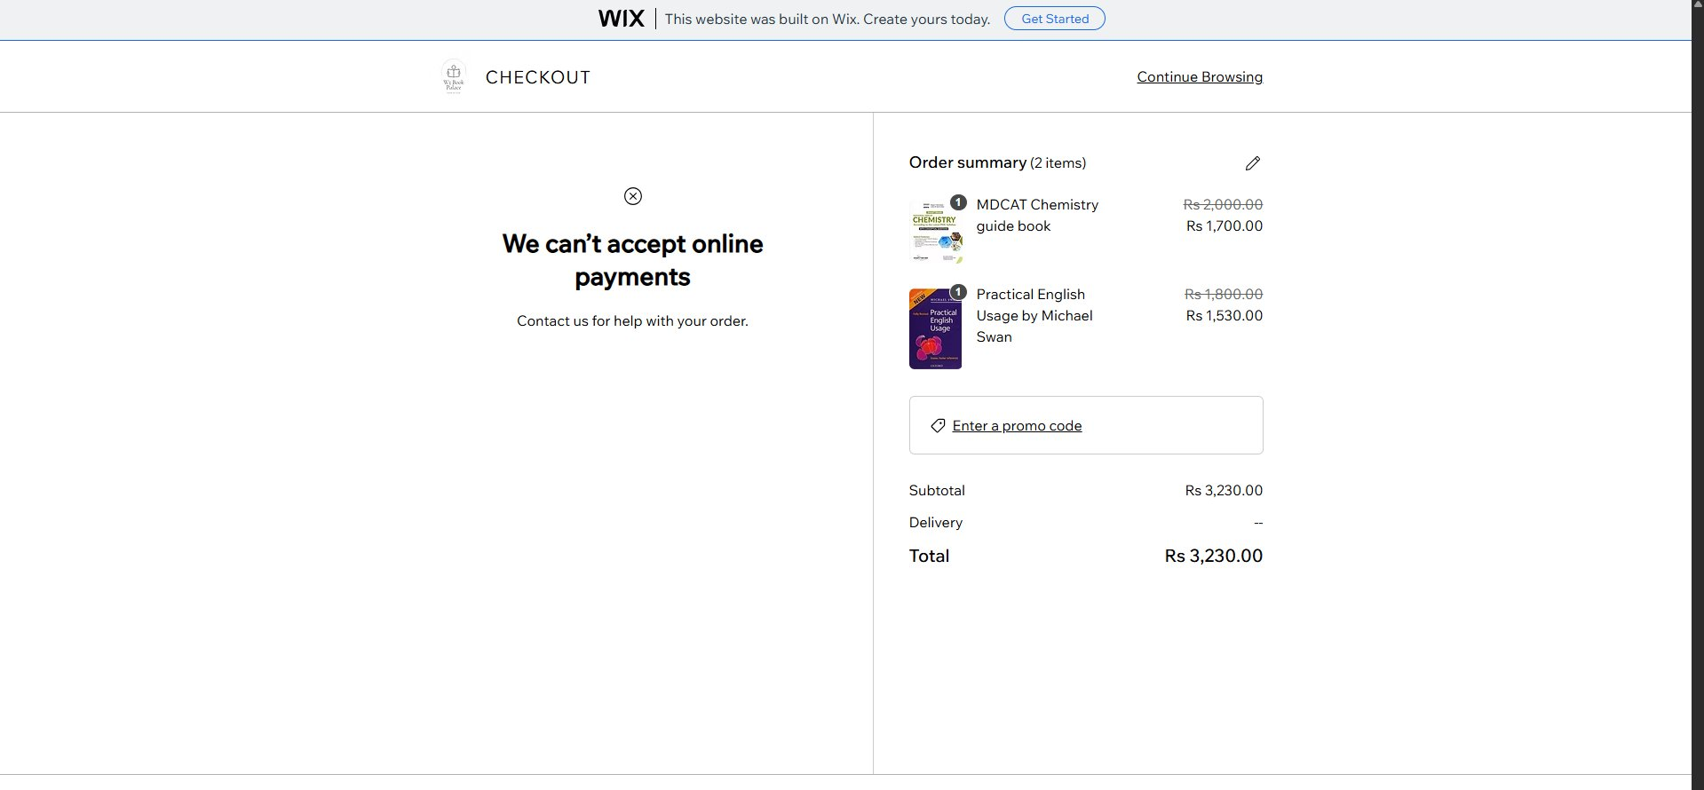
Figure 1: Checkout page showing the online payment error on DualPages Books

7.2 Why This Error Appears
This error is not a technical mistake or a bug in our website. It happens for one simple reason: we are using the free version of Wix, which does not support online payment processing. Here is a full explanation:
- Free Wix Plan Restriction — Wix only allows payment gateways (such as JazzCash, EasyPaisa, Stripe, or PayPal) on paid Business plans. The free plan cannot process real money transactions.
- No Payment Provider Connected — Even if we wanted to connect a payment method, that option is locked and greyed out in our Wix dashboard on the free plan.
- Store Works in Demo Mode — The Wix Store on the free plan is fully functional for display purposes. Products, categories, shopping cart, and the checkout page all work visually. However, the actual payment transaction cannot be completed.
- Academic Project Purpose — Since this website was built purely as a student project to learn how e-commerce websites are made, the free plan was sufficient for our goals. We did not need real payment processing.

This screenshot actually proves that our website is working correctly. The customer was able to browse products, add books to the cart, see correct prices in PKR, and reach the checkout page. The only limitation is the payment step, which requires a paid upgrade.

7.3 How to Fix This (Future Upgrade)
If this website were to be turned into a real business, we would upgrade to a Wix Business Basic plan and connect a Pakistani payment provider such as JazzCash or EasyPaisa, which would allow customers to complete their purchases online.

8. Conclusion
We successfully built DualPages Books as a complete, working online book store using the free Wix platform. Our team of three members — each working in a dedicated role — designed, developed, and published a website with 23 book listings across three relevant categories: Urdu Novels, Islamic Holy Books, and Competitive Exam Books.
The website demonstrates everything we learned in our AICT course about how e-commerce websites are structured, designed, and deployed. The only limitations we faced were due to the free Wix plan, which restricts online payments, custom domains, and ad removal. These are not errors on our part — they are expected restrictions of a free student-use platform.
Overall, we are proud of what we built as a team and believe this project clearly shows our understanding of web development, online stores, and digital product management.

References
DualPages Books. (n.d.). DualPages Books [Online bookstore]. https://wasifzaman2047.wixsite.com/mysite
Wix. (n.d.). Help center. https://support.wix.com
Wix. (n.d.). Wix pricing & plans. https://www.wix.com/upgrade/website

